Ajax/JQuery

Ajax is a set of web development techniques that uses various web technologies on the client-side to create asynchronous web applications. With Ajax, web applications can send and retrieve data from a server asynchronously without interfering with the display and behaviour of the existing page.

AJAX just uses a combination of:

* A browser built-in XMLHttpRequest object (to request data from a web server)
* JavaScript and HTML DOM (to display or use the data)

All modern browsers (Chrome, Firefox, Edge (and IE7+), Safari, Opera) have a **built-in** XMLHttpRequest object.

The XMLHttpRequest object can be used to exchange data with a server behind the scenes. This means that it is possible to update parts of a web page, without reloading the whole page

JQuery

A JavaScript Library which aims to simplify JavaScript programming

Main aim is to write less, do more

JQuery has lots of features

* HTML/DOM manipulation
* CSS manipulation
* HTML event methods
* Effects and animations
* AJAX
* Utilities

Implementing JQuery

Either referencing it via link or installing its package

Syntax

**$(*selector*).*action*()**

* A $ sign to define/access jQuery
* A (*selector*) to "query (or find)" HTML elements
* A jQuery *action*() to be performed on the element(s)

$("p").hide() - hides all <p> elements.

$(".test").hide() - hides all elements with class="test".

$(document).ready(function(){  
  
 *// jQuery methods go here...*

*//* ‘Ready’ is to prevent any jQuery code from running before the document is finished loading (is ready).  
  
*});*

Events

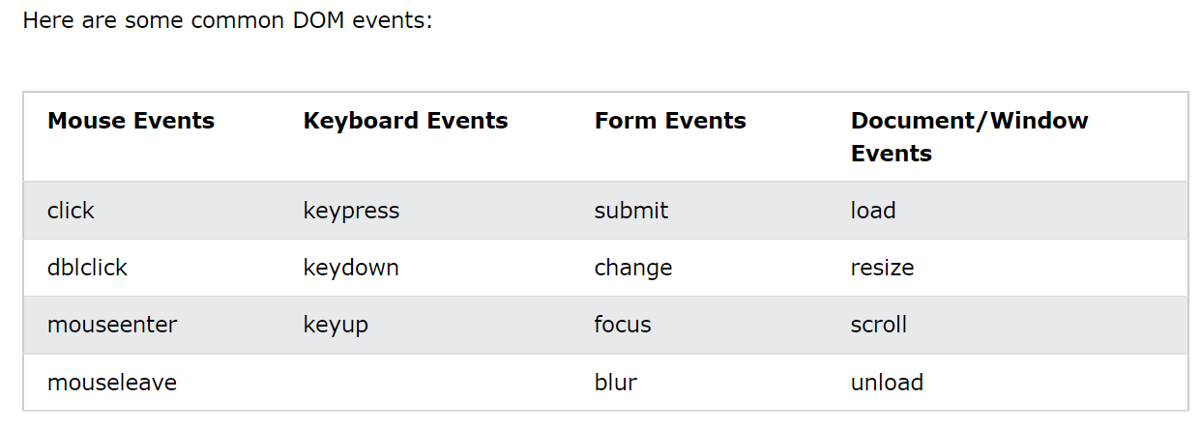

$("p").click(function(){  
 // action goes here!!  
});

Events

The $(document).ready() method allows us to execute a function when the document is fully loaded.

Ajax Jquery

Load()

Get() - gets data same with post but can return cache data

post() - I've noticed there are placedholders within the server to which we can send data using httppost